**LAB-2**

Q-1 Below is the source code for k-mean clustering using R along with the data file.



Below is the snap shot for result plot.

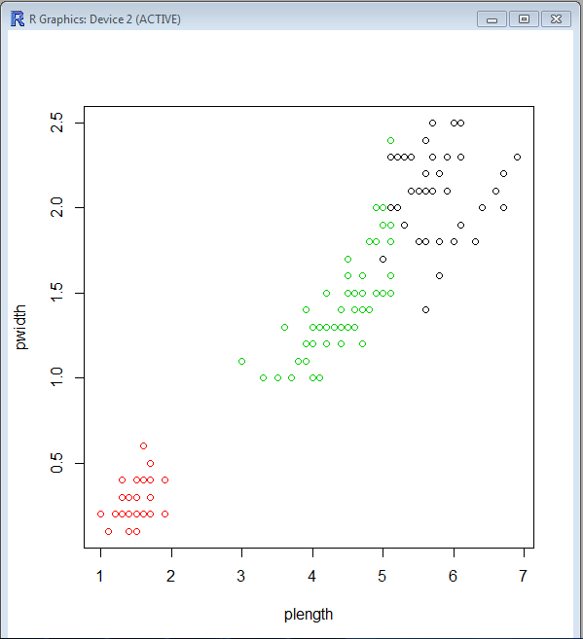

This is the data for sepal height and width with petal height and width along with species of flower group. To cluster them I excluded the column of species from initial data set and cluster them in 3 different groups.

Q-2 **Weather API application**

I have used yahoo’s weather API in this application to show particular city’s current weather. I have just used temperature functionality of API among all many more functionalities. Here I have created two packages, one for data and another for service. Application has two interfaces for service interaction and JSON string parsing. For source code please refer the GIT URL and **first** folder in same repository.

Below are the output snapshots:

First app in the list:

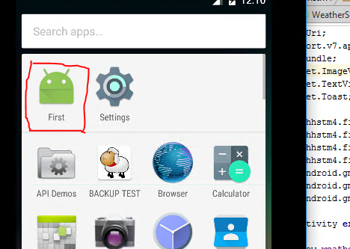

**Output:**

O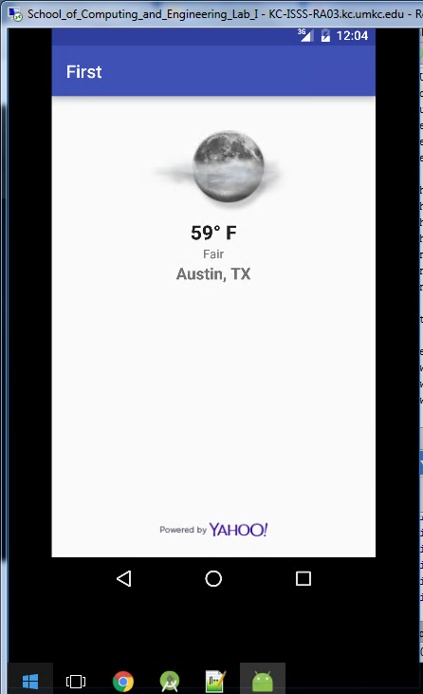

Below are the references for both assignments.

<https://archive.ics.uci.edu/ml/datasets/Iris>